A Raisin in the Sun Final Assessment

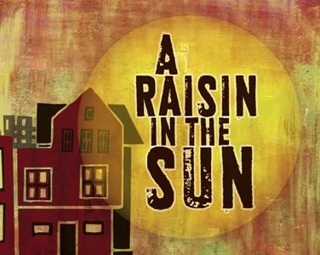
A Raisin in the Sun contains three acts and has an open-ended conclusion. In other words, we have no conclusive answer to the question “So how did it end?” In place of a written test, your duty is to wrap up the story by writing Act 4.

- Who: Will the play exclusively contain the same characters or will new characters be introduced?
- What: What themes will you continue to develop? Assimilation? Importance of family? Racial discrimination? The American Dream?
- Where: Where will Act 4 take place?
- When: Will Act 4 pick up right where Act 3 left off or will there be a gap in time?
- How: How will you wrap up the story?

Requirements:
- You will be writing Act 4, which will only contain one scene.
- Your story should contain a definitive ending.
- The following characters from the original play must be present in Act 4: Mama, Walter Lee, Bennie, Ruth, Travis, and Mr. Lindner You may add extra characters if you wish.
- Include stage directions to help the reader understand what is taking place.
- Your theme(s) should be clear to the reader.
- You will email Act 4 to me: pdalsky@efcts.us
- The rubric on the back of this paper will show you how I will be grading.

