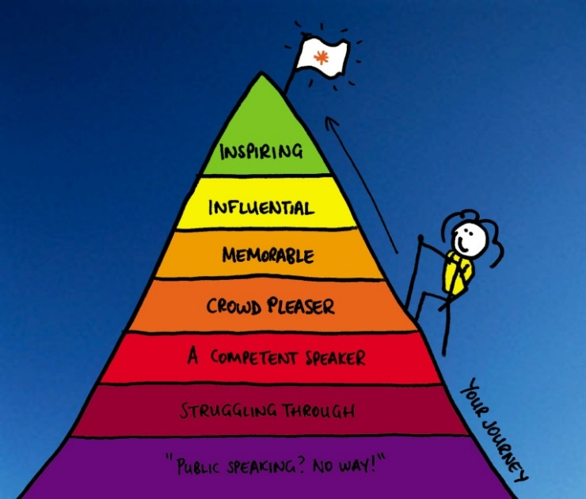

Goals
- To overcome any fears of public speaking and deliver a speech of high caliber.
- To prepare you to interact with those who are not your friends or family members, such as a boss or customer.
- To work on clearly stating what you need to say.

Why
Every job that exists depends on some form of communication. Face-to-face or live interactions make up a large portion of how you will communicate in the workplace, in the military, and at college. You need to be able to speak to others and get your point across. Giving a speech in ENG 3 will help prepare you for how to do that.

The Process
- Find a topic
- Complete the Speech Graphic Organizer
- Write 1st Draft
- Workshop Day
- Make changes
- Write index cards
- Practice again
- Present your speech (3-5 minutes)

Assignment | Due Date | Point Value
Topic selection sheet | End of class Wednesday, Feb. 11 | 15
Speech graphic organizer | End of class Thursday, Feb. 19 | 20
First draft | End of class Thursday, Feb. 26 | 25
Workshop | In class on Friday, Feb. 27 | 20
Index cards | End of class Tuesday, Mar. 3 | 20
Speech* | Beginning on Monday, March 9 | 50
 | Total | 150
*Not giving a speech will result in a loss of points for all assignments connected with this project.

Mon, Feb. 9 | Tues, Feb. 10 | Wed, Feb. 11 | Thurs, Feb. 12 | Fri, Feb. 13
Introduce Persuasive Speech Project | Work on Topic Selection sheet | Topic Selection sheet due by the end of class | Review for WL#8 test | WL#8 test
Mon, Feb. 16 | Tues, Feb. 17 | Wed, Feb. 18 | Thurs, Feb. 19 | Fri, Feb. 20
No School: Presidents’ Day | - Mr. Dalsky’s speech  - Begin graphic organizer | Work on graphic organizer | Graphic organizer due by the end of class | Work on First Draft of speech
Mon, Feb. 23 | Tues, Feb. 24 | Wed, Feb. 25 | Thurs, Feb. 26 | Fri, Feb. 27
Introduce WL#9 | Work on First Draft of speech | Work on First Draft of speech | First Draft of speech due by the end of class | Workshop Day
Mon, Mar. 2 | Tues, Mar. 3 | Wed, Mar. 4 | Thurs, Mar. 5 | Fri, Mar. 6
Work on index cards | Index cards due by the end of class | Practice Day | Review for WL#9 test | WL#9 test
Mon, Mar. 9 | Tues, Mar. 10
Begin speeches

